The likelihood of the Taiwan Semiconductor Manufacturing Company (TSMC) announcing plans to build a semiconductor fab in Europe in 2022 has fallen by 23% over the last month.

Ongoing innovation in artificial intelligence, natural language processing, and other technologies are often dependent on advances in semiconductor capabilities. The concentration of “fabs,” or fabrication facilities, also known as foundries, in Taiwan has led to concern about supply chain vulnerabilities that could disrupt multiple industries (National Defense, Discourse Magazine.) TSMC is a leading semiconductor manufacturer. The development of a fab outside Taiwan would be a significant mitigation to the concentration risk.

INFER Forecast Question: By 31 December 2022, will the Taiwan Semiconductor Manufacturing Company announce plans to build a semiconductor fab in Europe?
Based on 272 forecasts by 73 forecasters:
Possible Answer | INFER % Chance  15 June 2022 | INFER % Chance 14 July 2022
Yes | 51% | 28% (-23%)
No | 49% | 72% (+23%)

Why was this “heads up” issued?
Here are comments from forecasters who have recently updated their forecast assessments: (See Latest Forecasts and Rationales)
“I think EU and TSMC is just not the best fit. Also, the European Chips Act might now be delayed because of the lack of agreement about the details within the EU, and TSMC might want to wait to announce anything until they know the details.”  Michal_dubrawski  July 10, 2022, 9:49am ET | “News from Bloomberg regarding TSMC building a plant in Phoenix, AZ suggests to me that also building a new one in Europe might be too much of a stretch, especially given the war in Europe–too many wild cards.”  Cmeinel  July 7, 2022, 3:21pm ET | “It appears that Intel is going to build a fab in Germany, which decreases the overall chances of TSMC building a fab in the EU. Plus, the recent news that the TSMC Chairman said there were no concrete plans to build a fab in Europe.  MullenAustin  June 28, 2022, 12:49pm ET

Consensus Trend

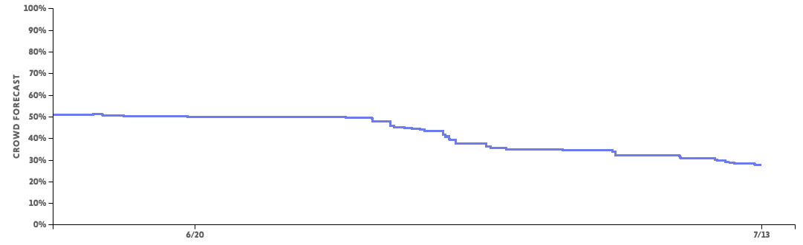

INFER, short for INtegrated Forecasting and Estimates of Risk, is a forecasting program designed to generate valuable signals and early warning about the future of critical science and technology trends and events for U.S. Government policymakers. INFER empowers scientists, researchers, analysts, and hobbyists from inside and outside the U.S. Government to have a direct impact on policy and decision-making. The public portion of INFER is one of multiple forecasting sites operating as part of this program. INFER is run by the non-profit Applied Research Laboratory for Intelligence and Security (ARLIS) at the University of Maryland in partnership with Cultivate Labs.

For questions about the project, email infer-public@cultivatelabs.com

